**Task 1 :**

* Open the terminal and use the pwd command to display the current working directory.
* Note down the directory path shown in the terminal.

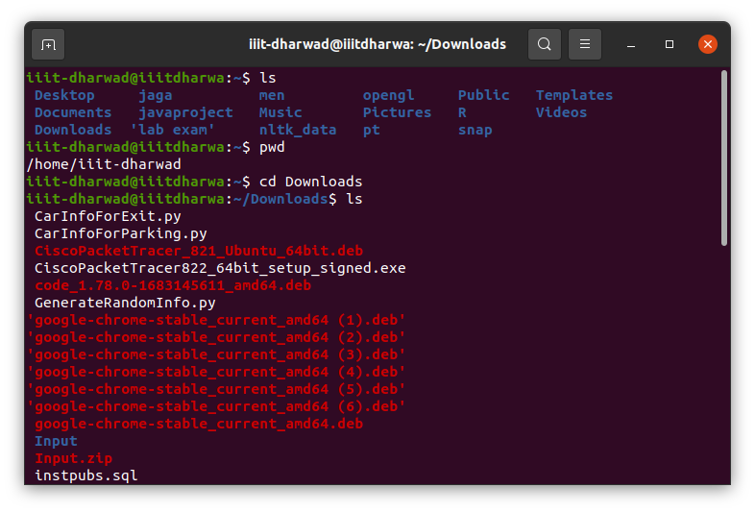

**Task 2 :**

* Use the ls command to list the files and directories in the current working directory.
* Observe the output of the ls command and note the displayed items.



**Task 3 :**

* Use the cd command to enter one of the listed directories obtained from Task 2.
* Use ls again to view the contents of the new directory.
* Use pwd to confirm the updated current working directory path.

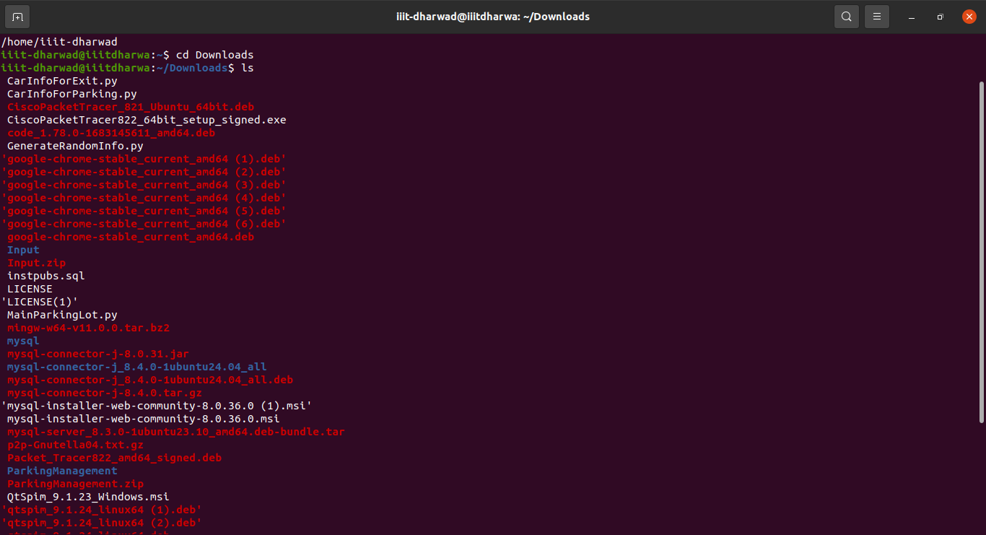

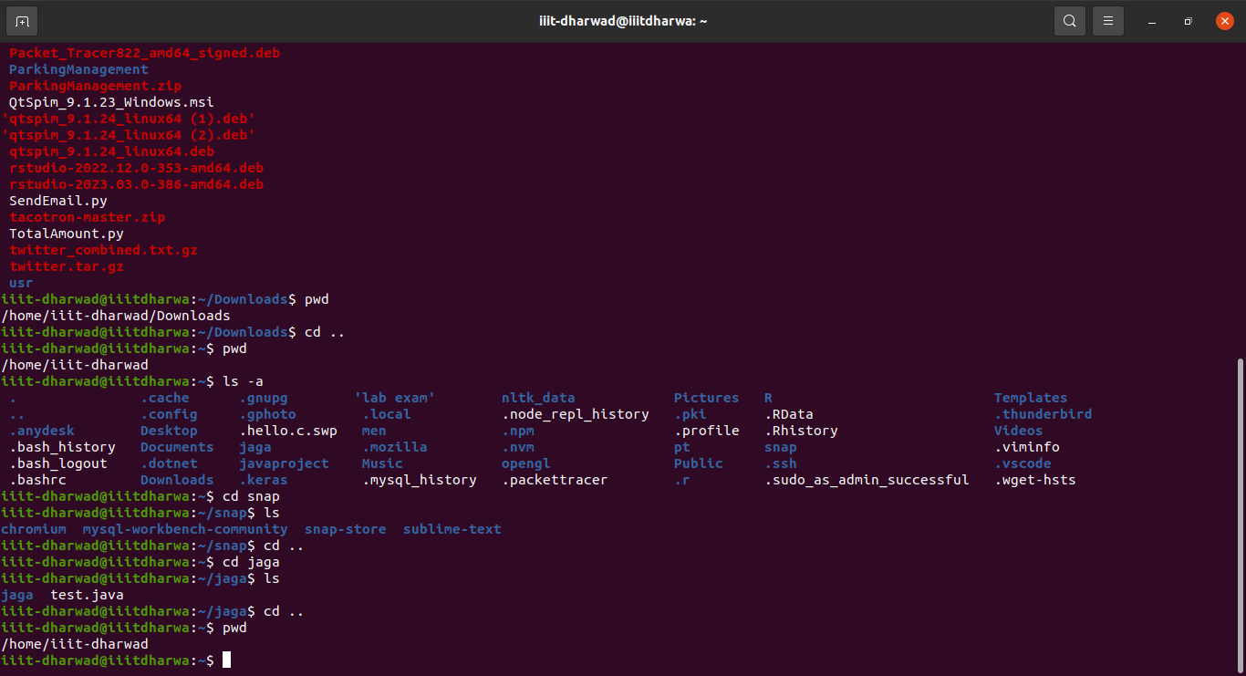

**Task 4 :**

* Use cd with the appropriate command to move back to the parent directory.
* Verify the change by using pwd to display the current working directory path.



**Task 5 :**

* Use ls -a command to display all files and directories, including hidden ones (starting with a dot . ).
* Observe hidden files and directories that weren’t displayed in the earlier.



**Task 6 :**

* Use cd followed by an absolute path to navigate to a specific directory in the file system.
* Additionally, use cd followed by a relative path to navigate to a different directory within the current location.
* Confirm the change using pwd to display the current working directory.



**Task 7 :**

* Create a file in a specific directory.
* Move files between directories.

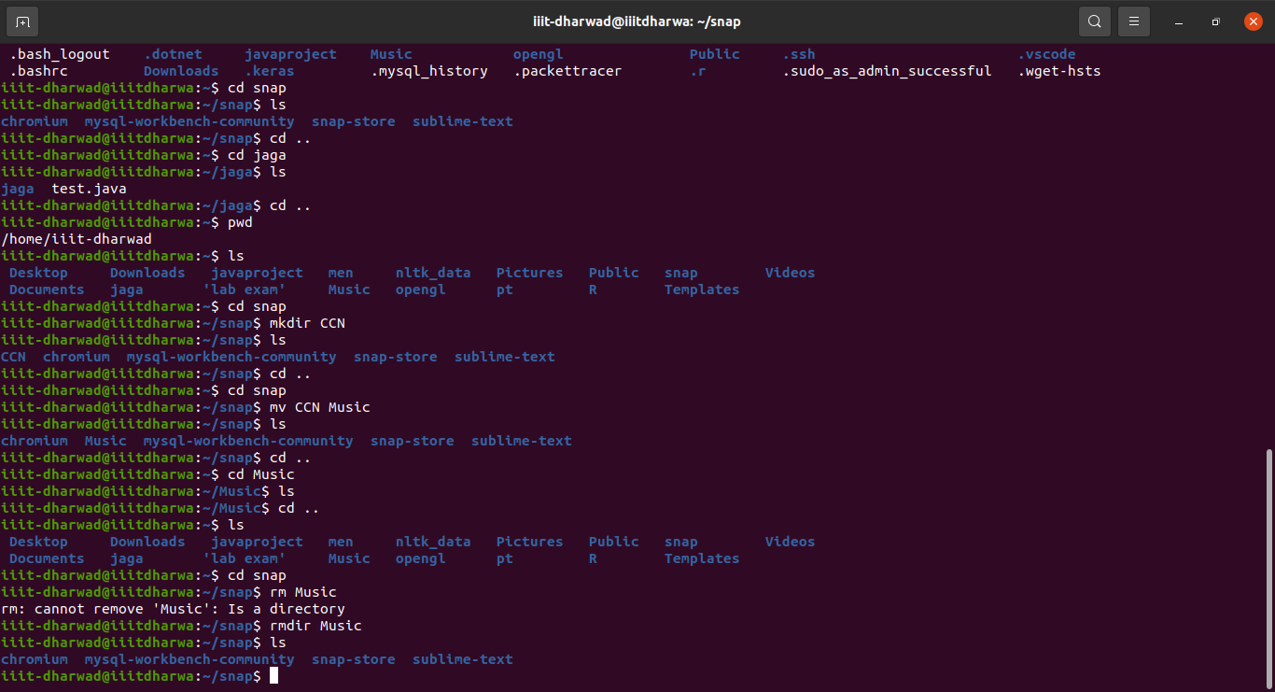

**Task 8:**

* Create nested directory structures.
* Delete files/directories, ensuring confirmation before executing rm -rf commands.

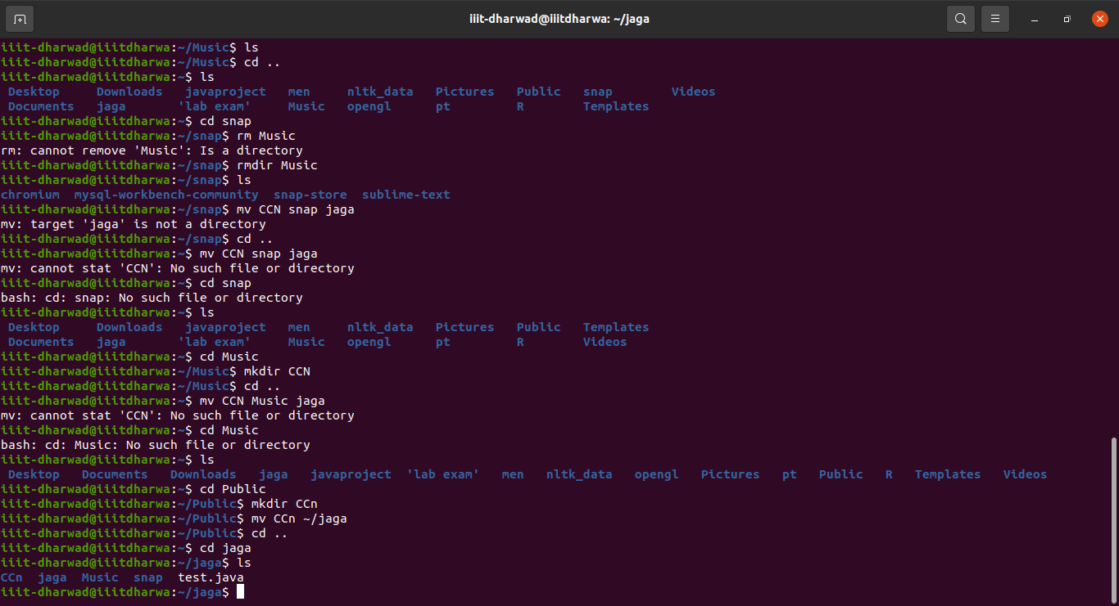

**Tasks 9:**

1. **find Command:**
   * Use the find command to search for all files with a .txt extension in the current directory and its subdirectories.
   * Find all files modified within the last 7 days in the /home/user/documents directory.
   * Search for files named "important_file.txt" in the entire file system

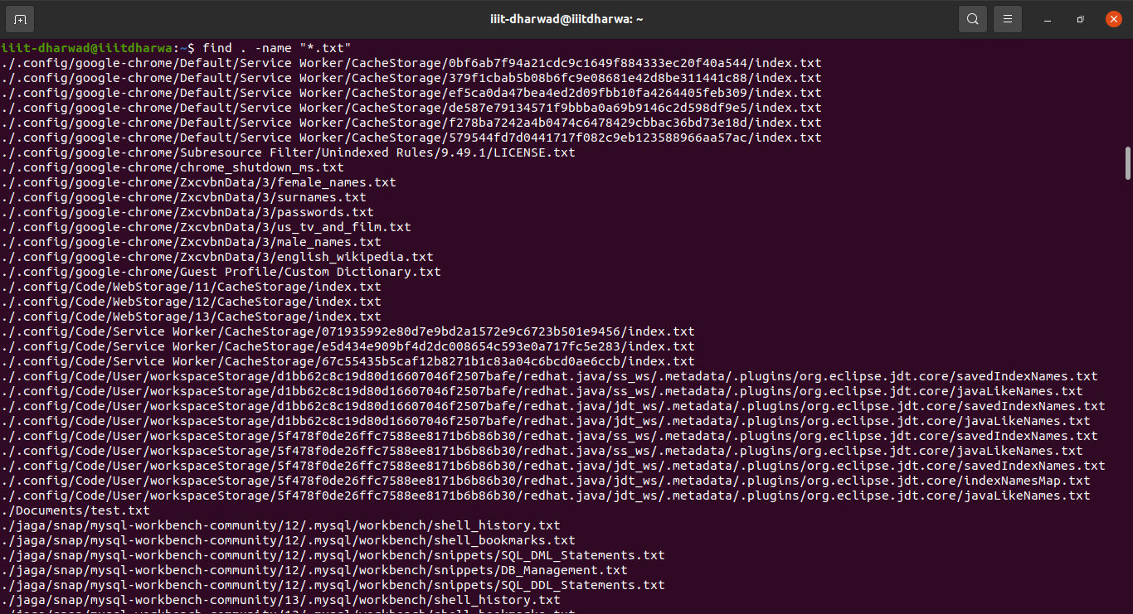

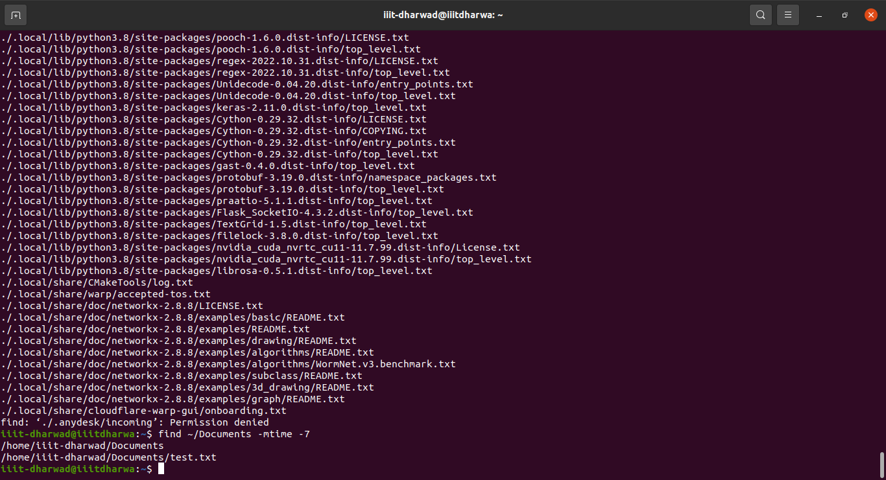

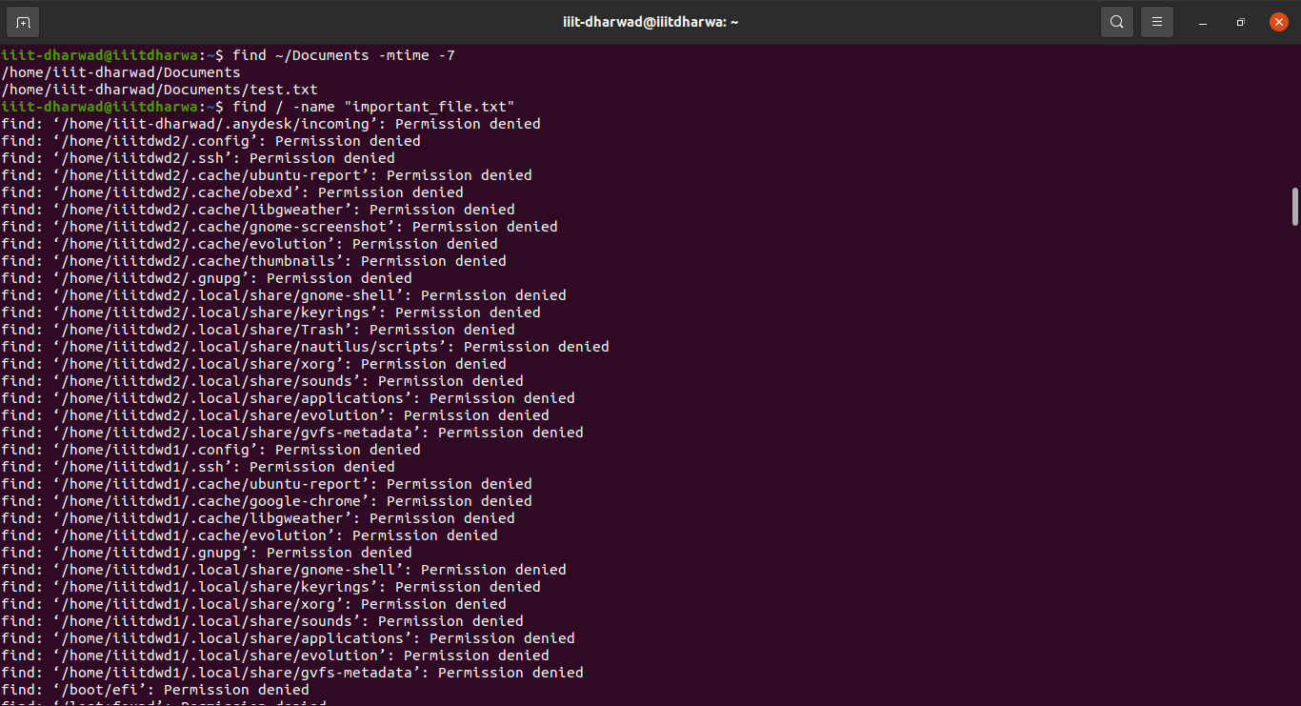

**2. grep Command:**

* + Create a sample text file containing multiple lines of text. Use grep to search for lines containing a specific keyword or pattern within the file.
  + Explore the usage of grep with the option to search for a pattern in all files within a directory.
  + grep [options] pattern [files]

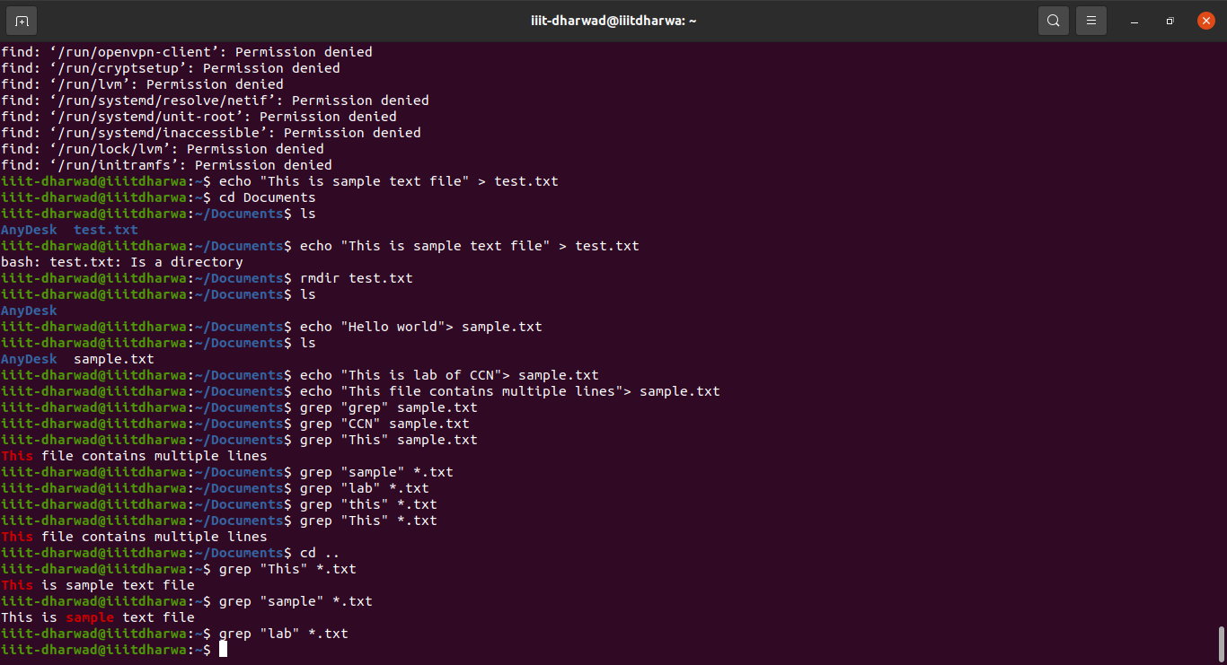

**3. tar Command:**

**Syntax:**

tar [options] archive_name files/directories

* + Archive the contents of the /etc directory into a file named etc_archive.tar.
  + Compress the etc_archive.tar file using gzip to create etc_archive.tar.gz.
  + Extract the contents of etc_archive.tar.gz into a new direc

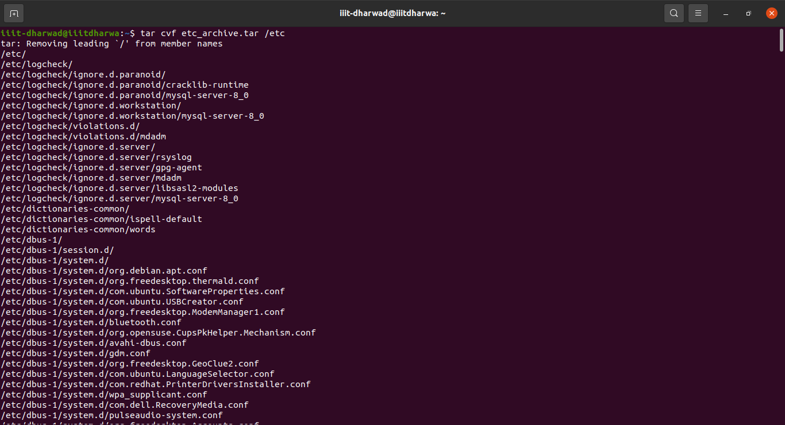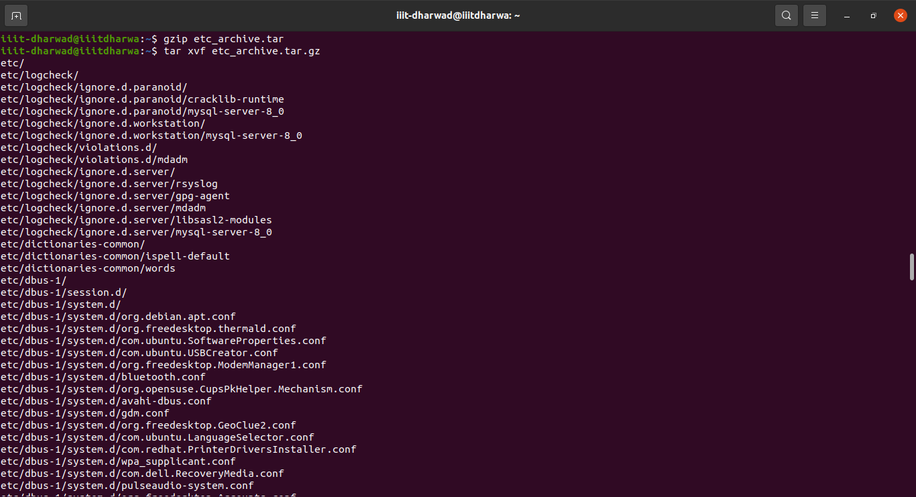

**4. gzip/gunzip Commands:**

**Syntax:**

gzip [options] file

* + Compress a sample text file using gzip and verify the compressed file's size.
  + Decompress the compressed file using gunzip and ensure the content integrity is maintained.

